Handout no. 4

|  |  |
| --- | --- |
| **Name** | Abdullah Bilal |
| **Reg. No** | 2016-EE-368 |
| **Marks/Grade** |  |

**EXPERIMENT # 4**

**Three Phase Current transformers**

**Objective:**

At the end of this lab session students will be able to

* Use De Lorenzo power system Protection kits.
* Implement “ Three Phase Current transformer” by using De Lorenzo power system Protection kits.
* Three phase Current Transformer operation.

**Introduction:**

Utilities are responsible for the generation, transmission and distribution of electricity to customers. Part of this responsibility is ensuring a safe but yet reliable power supply to customers. For the purpose of safety and protecting the transmission and distribution network from faults, utilities worldwide have sophisticated protective equipment. Collectively, these are known as secondary equipment and include the current transformers (CT), potential transformer (PT) and protective relays.

**Apparatus:**

* 1DL 1017R Resistive Load
* 1DL 1055TT Experimentation Transformer
* 1DL 2108T10 CT LOAD
* 1DL 2109T21 Three Phase Current Transformer
* 2 DL 2109T5A Moving Iron Ammeter (5A)

**Current Transformers:**

The basic principle of the current transformer is the same as that of the power transformer. Like the power transformer, the current transformer also contains a primary and a secondary winding. Whenever an alternating current flow through the primary winding, alternating magnetic flux is produced, which then induces alternating current in the secondary winding. In the case of current transformers, the load impedance or “burden” is very small. Therefore the current transformer operates under short circuit conditions. Also the current in the secondary winding does not depend on load impedance but instead depends on the current flowing in the primary winding.

The current transformer basically consists of an iron core upon which primary and secondary windings are wound. The primary winding of the transformer is connected in series with the load and carries the actual current flowing to the load, while the secondary winding is connected to a measuring device or a relay. The number of secondary turns is proportional to the current flowing through the primary; i.e., the larger the magnitude of current flowing through the primary, more the number of secondary turns.

The ratio of primary current to the secondary current is known as the current transformation ratio of the CT. Usually the current transformation ratio of the CT is high. Normally the secondary ratings are of the order 5 A, 1 A, 0.1 A, whereas the primary ratings vary from 10 A to 3000 Aor more.

The CT handles much less power. Rated burden can be defined as the product of current and voltage at the secondary side of the CT. It is measured in volt ampere (VA)***.***

***Circuit Diagram:***

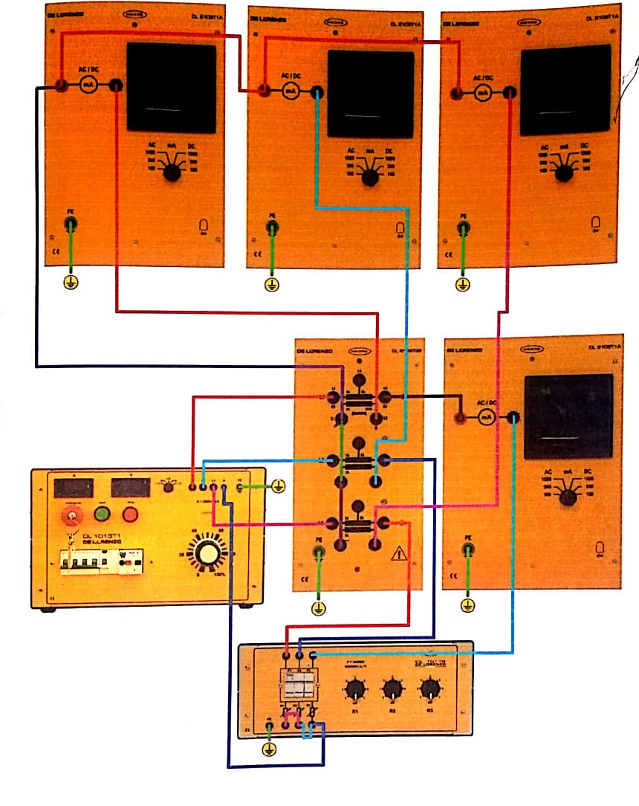

Figure 1 Three Phase CT

**Procedure:**

* Assemble the circuit according to the forgoing topographic diagram.
* Do not forget the fact the current transformer should not be opened at the secondary side!
* The resistive load located in the primary circuit and set to resistance value R6 for every phase.
* Connect the three-phase current transformer so that the transformation ratio is 1:1.
* Starting from 0V, increase the value of supply voltage to obtain 1A on the primary side of CT.
* Measure the three primary currents alternatively and read off the secondary currents with the neutral conductor N connected or disconnected.

|  |  |  |
| --- | --- | --- |
| **Balanced Load and Supply** | **N disconnected** | **N connected** |
| **IL1 (A)** | 0.6 | 0.6 |
| **I1 (A)** | 0.55 | 0.57 |
| **IL2 (A)** | 0.6 | 0.6 |
| **I2 (A)** | 0.55 | 0.57 |
| **IL3 (A)** | 0.6 | 0.6 |
| **I3 (A)** | 0.55 | 0.57 |

* The three currents measured must be approximately equal in both cases; slight deviations may be explained by components tolerances.
* Asymmetrical loads can also be measured with this circuit.
* Change only the resistive loads of the phases L2 and L3 to the value R5.
* Increase the supply voltage to obtain a primary current IL1= 0.6 A.
* Measure the three secondary currents, once with and once without the neutral conductor N connected.

|  |  |
| --- | --- |
| **For Unbalanced load and Balanced Supply** | **N-disconnected** |
| **I1 (A)** | 0.58 |
| **I2 (A)** | 0.43 |
| **I3 (A)** | 0.42 |

* Now, when the circuit is not alive, disconnect the conductor L3 at the output side of three-phase power supply.
* Repeat the above measurements.

|  |  |
| --- | --- |
| **For unbalanced Load and Supply** | **N disconnected** |
| **I1 (A)** | 0.58 |
| **I2 (A)** | 0.43 |
| **I3 (A)** | 0 |

* Now change the resistive loads of the phases L2 and L3 to the value R5.
* Increase the supply voltage to obtain a primary current IL1= 0.6 A.
* Now, when the circuit is not alive, disconnect the conductor L3 at the output side of three-phase power supply.
* Repeat the above measurements for balanced load and Unbalanced supply.

|  |  |
| --- | --- |
| **For balanced load and Unbalanced supply** | **N-disconnected** |
| **I1 (A)** | 0.58 |
| **I2 (A)** | 0.58 |
| **I3 (A)** | 0 |

**Observation:**

In this lab I learnt how to use three phase Current Transformer. I performed different scenarios including balanced load and supply, unbalanced load and balanced supply, balanced load and unbalanced supply etc with the impact of neutral connected and disconnected. I used 1:1 three phase CT and observed the pattern of currents values in different scenarios.